Prayer

As I begin work on this chapter I realize that a percentage of my readers will resist what I write. It is my hope they will read through all of the material, search out the truth or falsity of what I have said by reference to the biblical scriptures and abandon, modify or refute the validity of my study and life experience. I hope they will be like the Bereans of Acts 17:11. Some will say they have witnessed real life answers to their prayer. There is no way I can either deny or support their statements, because in the end this topic is decided by faith and faith alone. I do believe there is significant scriptural support for the position I have taken on prayer and I hope that you will be able to see the validity of my statements if making such changes in your belief system will result in a greater understanding of who you are in Christ which is my motivation for writing this chapter.

The believer today is (spiritually) in the New Jerusalem and the scriptures clearly say that we have now all of the blessings God has for us, and He has kept no good thing from us. If this be true then why is there a need for the practice of prayer? It doesn’t get any better than it is now in this physical life insofar as blessings. In fact, since we are spiritual beings living in a spiritual New Covenant, could it not be that the Godly blessings that we are told we have are spiritual in nature and not in the physical realm at all!

“…but those who seek the Lord lack no good thing” (Psalms 34:10b).

If God does this for those who are seeking Him, would it not be logical that we in the New Covenant who have Him indwelling us (living in us) must at least have the same if not a tremendous amount beyond that promise?

“No good thing does the Lord withhold from those who walk uprightly” (Psalms 84:11b).

Those of us in the New Covenant DO walk uprightly because the Godhead lives in us and it is NOT because of our actions! We walk uprightly only because He who is always upright in all things lives within us and for no other reason are we righteous!

“I have been crucified with Christ; it is no longer I who live, but Christ who lives in me; and the life I now live in the flesh I live by the faith of the Son of God, who loved me and gave himself for me” (Galatians 2:20).

Examine what Jesus said in the following passage:

“I knew that thou hearest me always, but I have said this on account of the people standing by, that they may believe that thou didst send me” (John 11:42).

Jesus was in the Father and the Father was in Him. There was no need to speak verbal prayer except for “the people standing by.” Our situation today in the New Jerusalem is much the same as the Godhead is in us and we believers are in the Godhead. The only reason we sometimes speak prayers is for those who are standing by that did not yet believe or do not understand their position in the Godhead under the New Covenant!

On the topic of prayer the organized, institutional, man-made and perpetuated church has developed a body of information that it feeds to its adherents as truth, when all it really amounts to is using a series of Old Covenant passages that are out of context when we have been in the New Covenant now for approximately 2000 years! Why would I make that statement?

Let’s look at what is known as “The Lord’s Prayer” as found in Matthew 6:9-13.

“Our Father who art in heaven” Does the Scripture really teach us that the Father is in heaven? The organized, institutional, man-made church seems to believe so! The Old Covenant scriptures also teach this to be true, but with an exception – God did come down to Earth at certain points/events in Old Covenant times but He did not hang around or indwell those who believed in Him. The above prayer then was applicable to the Old Covenanters. But we today DO NOT live in the Old Covenant era. We live in the New Covenant era where Christ is in the Father, the Father is in Christ, and they are in us once we become believers! So, this prayer is an Old Covenant prayer and was for a time when God did not indwell His believing church of which He is the spiritual head. The truth is God is now here on Earth and resides in each and every believer.

Can the Father be in heaven? Of course He can and is! The entire Godhead is Spirit and can be any place and every place they desire to be. The spirit realm does not have the restrictions that a physical being has here on Earth. My point is to believe in the Father ONLY being in heaven is erroneous and falsely causes the believer to NOT believe in the indwelling Godhead if the believer believes that this passage applies to the New Covenant, which it does not.

“Thy kingdom come” When this phrase was uttered by Christ, the kingdom of God was just coming upon the scene. It was fully established on Earth at the Parousia of Christ (circa AD 70) which also marked the total end of the Old Covenant. So Jesus is teaching the Old Covenant way of prayer to the people of that era.

The facts are that Jesus never had to ask the Father what He had to do because Jesus had the Father in Himself and was in constant communion with the Father just as we are today in the New Covenant with the entire Godhead living and in communion with us!
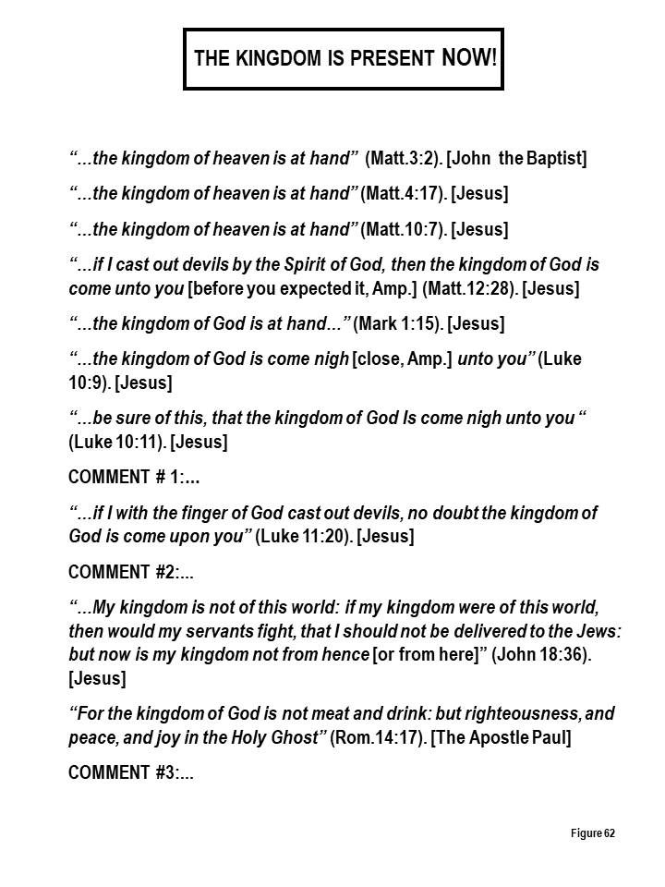
If the kingdom is now present on Earth, and it is, why are so many Christians still praying “thy kingdom come?” The answer is obvious. Too many Christians have no concept of how to handle the word of God with understanding. They think it is all one big letter written directly to them and they have no concept of how “audience relevancy” and “rightly dividing” impacts what is read from the Scriptures!
What do scientific studies say about prayer? Many in Christianity make the claim that praying for somebody who is sick can have positive effects on the health of the person being prayed for. A number of studies on intercessory prayer have been published. The results of these studies indicate either no effect or a potentially small effect. A 2006 analysis of 14 studies concluded that there is “no discernible effect.” A 2007 systematic review of intercessory prayer reported inconclusive results, noting that 7 of 17 studies had, small, but significant, effect sizes but the review noted that the most methodologically rigorous studies failed to produce significant findings.

How then do we understand the statements made about the “power of prayer” that people give testimony of as prayers that were answered for them as individuals? Could it be answered by “the power of coincidence?” Coincidences, even remarkable ones, happen all the time. There are numerous cases where conditions are alleviated without any known prayer being involved!

Though many people practice prayer and believe it affects their health no scientific evidence supports this belief. Masters and Spielmans have conducted a meta-analysis of the effects of distant intercessory prayer, but detected no discernible effects.

In 2006, a study called The Study of the Therapeutic Effects of Intercessory Prayer (STEP) was conducted under the auspices of Harvard Medical School, the most comprehensive study of its kind. The study required 10 years and $2.4 million, and was mainly underwritten by the John Templeton Foundation, a supporter of studies that explore interactions between religion and science.

STEP studied 1,802 patients; all admitted for coronary artery bypass graft surgery that were divided into three randomized groups. Two groups received prayer from committed Christians with experience praying for the sick. But only one of the groups knew they were being prayed for. The result was the group whose members knew they were being prayed for did worse in terms of post-operative complications than those whose members were unsure if they were receiving prayer. The knowledge that they were being prayed for by a special group of intercessors seemed to have a negative effect on their health!

What abuses of prayer have occurred?

There has been a plethora of abuse insofar as prayer belief. Consider the case of an eleven year old, Madeline Kara Neumann of the town of Weston, county of Marathon in Wisconsin who died at the age of eleven in 2008 because her parents chose to use prayer instead of taking her for medical help for her diabetic ketoacidosis condition which is medically curable. The parents are quoted as saying that her death is attributed to the fact that they apparently did not have enough faith in their prayers!

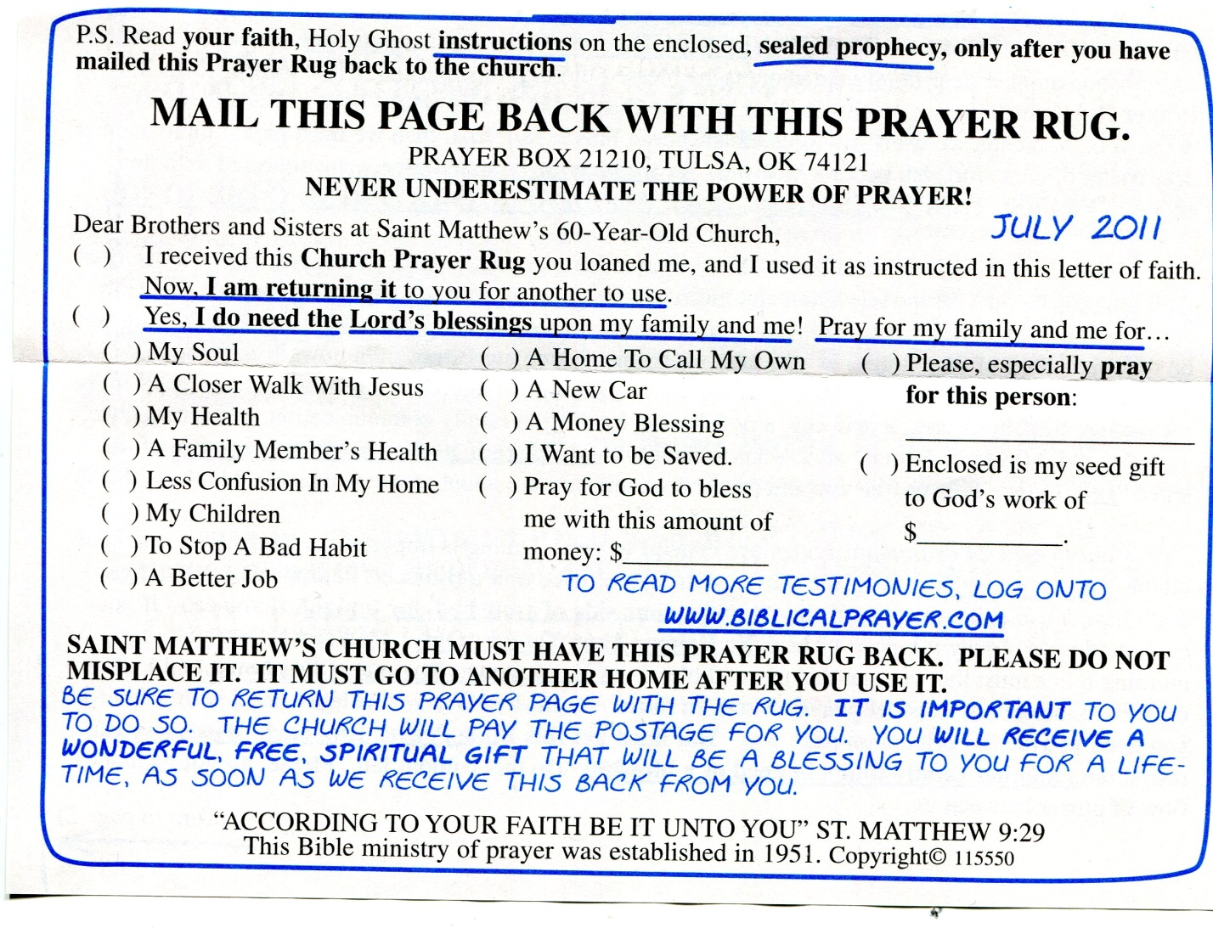
One day I received in my personal mail the offer above which included a “prayer rug.” I think it was the largest SCAM I have ever seen take place attempting to dupe Christians. Take note of the various requests that can be made to this charlatan group in the check off boxes!

Has the practice of prayer become riddled with formulas, programs, and oddities?

There have been numerous programs instituted by those in Christian circles many of which are founded and promoted on false biblical practices. What appears below is just a small portion of some that the writer is familiar with, I am sure there are many more that could be cited.

Prayer Furnaces: The Prayer Furnace is described by its adherents as a model in the spirit of the Tabernacle of David with singers, musicians, and intercessors ministering to the Lord. Our cry, they say, is that of the Moravian missionaries: May the Fire on the Altar Never Go Out! From this statement alone we should be able to see that this program is a man-generated idea, supposedly generated by the Moravians and is based upon an Old Covenant text.

Additional literature on Prayer Furnaces indicate that, “Jesus has called us to call forth a generation that would carry his fire and presence – the fuel for such a movement is through day & night prayer.” (generationfire.com.au/the-furnace-24-7 prayer-furnace)

Consider what is said of the “Harp and Bowl” 24 hour prayer initiative that was initiated by Mike Bickle, founder of the Metro Christian Fellowship in Kansas City. The “system” is advertised as the “Restoration of the Tabernacle of David.” Right out of the chute we see man attempting to keep the people in his fellowship busy by resurrecting a section from the Old Covenant! But, the man-made institutional church is good at keeping its people busy so that they think they are doing good works and having an impact on the coming kingdom (which is already here) in some dynamic way. The stated goal of this program is to “see a 24-hour a day city-wide house of prayer in the spirit of the Tabernacle of David in every city of the earth before the Lord’s return.” Sorry Mike, you’re too late!

The Harp and Bowl came out of what is known as the Latter Rain teaching, which was a movement surrounded by a climate of false prophecy. In May, 1983, when Bickle met with a person named Bob Jones, the Lord supposedly gave a promise to Bickle’s church that He (God) would release a 24-hour a day ministry in the spirit of the Tabernacle of David (Acts 15:14-18). The use of this passage is clearly out of context for use today in the New Covenant.

Another account credits the birth of Harp and Bowl to Paul Cain in 1996, but speaks of the vision for it being given in 1982, at the founding of Mike Bickle’s church, thus neatly avoiding the Bob Jones scandal that took place at the Bob Jones Christian University. That institution was blamed of telling abuse victims at the school to not report their abuse to the police because doing so would damage families, churches, and the university (December, 2014).

I think this entire mess of a program can be summed up in finality for us if we read the central idea of the Harp and Bowl work (and I do mean work).

“David built a tent, a physical place where Gods glory dwelt and where people could go to meet with God…Solomon erected an actual temple building in the pattern of his father David’s tabernacle and on two occasions, the Weight of the Glory of God filled the temple as the priests ministered in prayer, praise and prophecy…This is what God is asking us to do today…We along with all of creation are longing for the unveiling of Gods power as God waits in heaven for the bowl of the prayers of the saints to be filled up so He can show His power. Prayer is directly related to the release of Gods power in scripture.”

Anyone desiring to further investigate this “prayer ministry” should inquire into the content of intotruth.org/apostasy/harp-bowl.htm Please be honest, does the above “arm twisting” of God by Christians to motivate God to do something sound like the relationship we have with God in the New Covenant?

The author of this book spent a period of time believing and trusting in the process and power of prayer. I recall a full year period of time when I and my wife spent one full hour of prayer daily under Dr. Larry Lea “Could You Not Tarry One Hour.” Some remnants of this program can be found on the web site “crosswalker.com and then clicking on the “Prayer Studies” icon. This program was devised by man using the passage of Matthew 26:40, 41, when Jesus took the disciples to task for not standing with Him in prayer. After a full year of devotion to this program I determined that my “efforts” were fruitless. Another “program” from the Old Covenant.

This program is still being touted on the Internet as, “After 20 years, 61 different countries Dr. Larry Lea continues spreading the message of prayer and raising up intercessors to cry out in prayer before the Lord…These are exciting times.”

The above program is a bit like the story of the Jewish man who spent 20-25 years praying at the Wailing Wall in Jerusalem praying for world peace, the brotherhood of man, the eradication of illness and disease and peace between Jewish and Arab people. When asked how it felt to be praying for these things for so long the man replied, “How does it feel? It feels like I’m talking to a wall!”
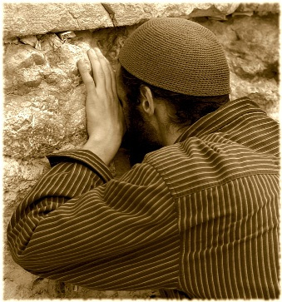

Another prayer “program” to look at would be the “Prayer of Jabez.” The supposed basis for this one is 1 Chronicles 4:10, which reads:

“And Jabez called on the God of Israel, saying, Oh that Thou wouldest bless me indeed, and enlarge my coast, and that Thine hand might be with me, and that Thou wouldest keep me from evil, that it may not grieve me! And God granted him that which he requested.”

Jabez asks God to bless him (we are already blessed in the New Covenant), he asks God to enlarge his territory or increase his responsibility (can we ask for more when we already have everything we need!), Jabez goes on to pray that God will be with him and stay close (how much closer can God get to us in the New Covenant since He already lives inside of us?), and lastly Jabez asks that God keep him from harm so that he will be free from pain (how is that for a selfish request?). These are the stated objectives of Jabez prayer from a web site on the Internet.

What we have here again is man contriving an Old Covenant prayer system into a “program” to keep those in the institutional church busy by using an Old Covenant passage.

Though some people practice prayer and believe it affects their health, no scientific evidence supports the efficacy of prayer. Today as Christians in the New Covenant we have a relationship with the Godhead that immeasurably exceeds that of the God the Old Covenant believers tell us about. Ours is a moment by moment 24-7 relationship that can be no more intimate here on Earth than it is right now! Look below at what God has already provided for New Covenant believers.

- We are a new creation (2 Corinthians 5:17).
- We are justified (Romans 5:1).
- We are complete in Christ (Colossians 2:10).
- We have direct access to God (Ephesians 2:18) and no longer have to go through an Old Covenant priesthood.
- We are saints (Ephesians 1:1).
- We are hidden with and in Christ (Colossians 3:3).
- We are free from condemnation (Romans 8:1, 2).
- We are united with the Lord (1 Corinthians 6:17).
- We are God’s temple and God lives in us (1 Corinthians 3:16).
- We are seated with Christ in heavenly places (Ephesians 2:6).
- We are the body of Christ, and members individually (1 Corinthians 12:27).
- We are citizens of heaven (Philippians 3:20).
- We are free from any charge against us (Romans 8:33, 34).
- We cannot be separated from the love of God (Romans 8:38, 39).

The list above contains just a few illustrative characteristics of who we are in the New Covenant!

One thing should be evident from the above list. Each item refers to the spiritual, unseen, realm. They are not of the Old Covenant but of the New Covenant! This is a significant truth that we must be aware of and never forget! Let’s take a look at the things that are typically asked for in prayer.

Heal me. We are all going to physically die someday.
Save my children. Should God override their will to love Him or not to love Him? Is this the manner in which He has set up the New Covenant?
Get me a new job. Should you do that or God? Where is the personal responsibility here? Even the birds have this one correct. God provides for the birds but He does not throw their food into their nests!
Fix my marriage. Against the will of the people involved?
Bless my business. Perhaps you should find a new business or advertise your product/service. Again, personal responsibility and will are involved.
None of these are New Covenant. They are the teaching of man marketing an incorrect New Covenant gospel. The unfortunate fact here is that hoards of New Covenant Christians, perhaps lusting after physical things, buy the product that these false teachers are selling!

My conclusion from my study and attempts to apply the various teachings that have been put forth on this topic have led me to believe that everything we have need of has already been supplied to us because of our intimate relationship in God! What many Christians do not seem to understand that the vast majority of our blessings are not in the physical realm but in the spiritual realm!

The man-made organizational church groups are also part of the problem with misunderstanding and abusing prayer. These organizations have built in to most of them an insidious way of inserting their organization into the place of an intermediary between the believer and the Godhead, in effect acting as a usurper of Christ Himself being our all in all (Colossians 3:11). When considering all of the bells and whistles organizations feel compelled to maintain in order to provide a full menu of “services” to their adherents, they need to maintain a cash flow to finance the costs of these services to their clients. The more they can sway their followers to believe they need the organization for the proper health of their Christianity the easier job the organization has in accumulating the necessary funds. Out of one side of their mouth they advocate dependence upon God while at the same time the other side of the mouth advocates a close allegiance to the organization. By promoting the corporate service of prayer to its adherents, these organizations form and advocate such activities as praying for another, mass prayer for a particular response from God, prayer circles, prayer groups, prayer telephone trees, all of which ingrain in the adherent that you need the services available through the organization in order to continue and flourish as a Christian. All of these approaches to God heavily rely on using other intermediaries to get God to give you what you want!
Another Bible passage comes to mind that I believe should determine our understanding of prayer.
“According as his divine power hath given unto us all things that pertain unto life and godliness, through the knowledge of him that hath called us to glory and virtue” (2 Peter 1:3, KJV). Can we not rest in Christ to meet every need we have? Does this passage not say that is exactly what He will do and has done?
Perhaps an analogy taken from the physical realm may be helpful in cracking the door open for some readers to peek into the spiritual realm in a much greater way. In the physical realm we are sometimes gifted with a personal relationship with another human being where we are so close in our relationship with that person that we can anticipate there next move or comment in many situations. The most prevalent of these relationships is most often found in the marriage relationship (where the word of God tells us that the two become one!), where words are not always necessary to communicate with each other. If you have ever experienced such a relationship I am sure that you will understand what I am attempting to describe. As believers we are in a relationship with God that far exceeds my analogy. We are so intimately in union with God that we too are one with Him. What we have in communion and oneness with and in God makes any physical relationship we can have here on Earth with another physical human being almost insignificant! Our problem is that we have not had our minds renewed to this as fact and therefore find it difficult to understand and live out in this physical life. The first step is available to all believers to participate in the spiritual realm right now if we only believe!

“Even before a word is on my tongue, lo, O Lord, thou knowest it altogether” (Psalms 139:4). (So what is verbal prayer all about?)
NOTE: As you finish reading the material above by man you should heed the action of the believers at Beroea who “examined the scriptures daily to see if these things were so” (Acts 17:11).

